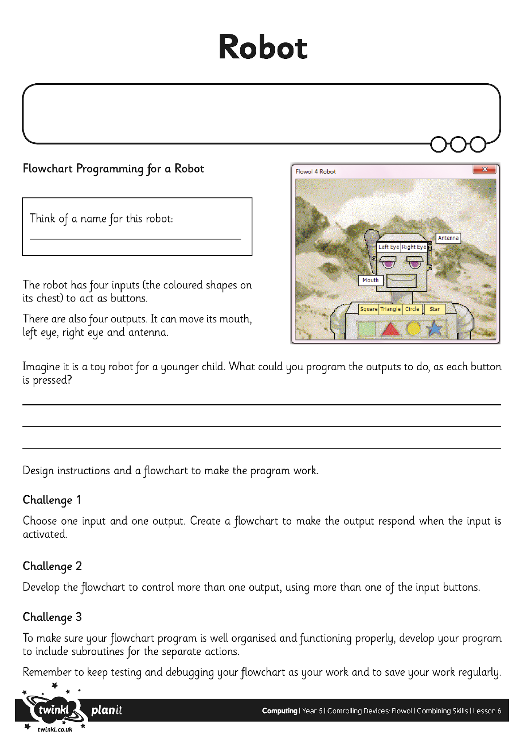
I can design, write and debug my own flowchart program for a given task.

